Software Requirement Specification

FOR

Share Karo App
Version 1.0 approved
Prepared by Share Karo App members:
Akshay Gupta: U101114FCS039
Anshul Sharma: U101114FCS046 (S2)
Ayushi Jain: U101114FCS055
Ishitaa Sayal: U101114FCS070 (S3)
Jatin Kakkar: U101114FCS072 (S3)
Jharana Shrivastava: U101114FCS073 (S3)

<NIIT UNIVERSITY>
<17 September 2016>

Table of Contents
1. Introduction
1.1 Purpose
1.2 Document Conventions
1.3 Intended Audience and Reading Suggestions
1.4 Product Scope
1.5 References

2. Overall Description
2.1 Product Perspective
2.2 Product Functions
2.3 User Classes and Characteristics
2.4 Operating Environment
2.5 Design and Implementation Constraints
2.6 User Documentation
2.7 Assumptions and Dependencies

3. External Interface Requirements
3.1 User Interfaces
3.2 Hardware Interfaces
3.3 Software Interfaces
3.4 Communications Interfaces

4. System Features
4.1 System Feature 1
4.2 System Feature 2 (and so on)

5. Other Nonfunctional Requirements
5.1 Performance Requirements
5.2 Safety Requirements
5.3 Security Requirements
5.4 Software Quality Attributes
5.5 Business Rules

Introduction

Purpose
The purpose of our project is to provide a platform for university students to sign up and login to share their modes of entertainment like movies, novels and TV Series that are use for leisure in hostel. It’s helpful in sharing academic resources, which would be beneficial for juniors and also provides them with conveyance sharing facility to a common route. The app is local area or university specific.

Document Conventions
IEEE convention is taken into consideration while writing this document. Arial font with 11font size is used for writing this document so as to make it apprehensible and eloquent. This document gives each and every requirement statement equal priority and higher-level priorities are highlighted wherever needed.

Intended Audience and Reading Suggestions
The document is intended for various readers such as developers, testers, project managers and documentation writer. App users are target audience and end viewers for the entire documentation and product. The SRS documents contains an content page where each and every requirement is sequenced from top to bottom i.e. from overview to sub-sections and documented according to the priorities

Product Scope
“Share Karo App” is specifically designed for university students to provide them with a eloquent platform to share their means of leisure in hostel with other students. Its helps the students to know and interact with each other and exchange shareable items like novels, music, TV Series and study materials. It helps the student to socialize with people beyond their circle. The app is a generic sharing and socializing portal for local area where physical connection is easily established. The app majorly focuses on university students.

References
This System Requirements Specification document majorly refers to IEEE standards of documentation. The Use case documents are designed over Argo UML software and derived from the same.
The references are:
- https://www.google.co.in/url?sa=t&rct=j&q=&esrc=s&source=web&cd=1&cad=rja&uact=8&ved=0ahUKEwiD9syNjpbPAhWLt48KHbmQCUAQFggdMAA&url=http%3A%2F%2Fwww.csse.monash.edu.au%2F~sitar%2FCSE4002%2FLectures%2Fsrs_template-1.doc&usg=AFQjCNF2DZX7_wbYlZyeAcrgjpYYTOhF6g
- http://searchsoftwarequality.techtarget.com/answer/Software-requirements-specification-and-the-IEEE-standard
- https://www.google.co.in/url?sa=t&rct=j&q=&esrc=s&source=web&cd=4&cad=rja&uact=8&ved=0ahUKEwiD9syNjpbPAhWLt48KHbmQCUAQFggvMAM&url=https%3A%2F%2Fredmine.studenti.famnit.upr.si%2Fattachments%2Fdownload%2F138%2FIEEE%2520Standard%2520SRS%2520Template.doc&usg=AFQjCNEZkGaUM7s_C5yXUV6hbbgJ3kfQhw
- https://www.google.co.in/url?sa=t&rct=j&q=&esrc=s&source=web&cd=6&cad=rja&uact=8&ved=0ahUKEwiD9syNjpbPAhWLt48KHbmQCUAQFgg6MAU&url=http%3A%2F%2Fitech.fgcu.edu%2Ffaculty%2Fzalewski%2Fism4331%2Fwritingsrs.doc&usg=AFQjCNFCiaSyICS3fjOGPtLJAZxBmAXPJA
- http://techwhirl.com/writing-software-requirements-specifications/
- https://www.google.co.in/url?sa=t&rct=j&q=&esrc=s&source=web&cd=10&cad=rja&uact=8&ved=0ahUKEwjI7PuqjpbPAhVJPY8KHeydDTkQFghTMAk&url=https%3A%2F%2Fcs.gmu.edu%2F~dfleck%2Fclasses%2Fcs421%2Fspring10%2Fproject%2Fsrs_template.doc&usg=AFQjCNFLKrMJFVl2haJg_G4905Q2PCddnQ&bvm=bv.133178914,d.c2I

Overall Description

Product Perspective
The seeding idea of the product is derived from the basic needs and requirements of fellow college friends who are unable to procure the entertainment stuff they require due to lack in communication and contacts. This idea has been implemented on smaller scales in different university across the country and is now being developed as a completely new model with features of cab sharing and socializing. This app is basically going to be the interface between two users to intend to exchange data with mutual consent and interests.

Product Functions
The functions that product is capable of performing are:
The user can sign up with the university/domain login and share their contact (email/phone no) if they feel like. The user needs to explain their interests in particular movie/novel genres so that other users can request them. The user is also allowed to upload the ppts and presentations they created for the juniors to refer. He/she can draw out the details of their journey so as to check if anybody else matches the same. The user can look up under specific headings (entertainment, studies, conveyance) and check if their requirements match any of the ones uploaded and can then contact the concerned person. The user is also allowed to make requests to a specified person for contact regarding the requirement.
For example, the Entertainment section is presented as:

User Classes and Characteristics
The app basically focuses upon the student within specific/local contact areas. The other user classes can be of faculty and parents who are interested in similar entertainment options and require conveyance modes. The most frequent users will definitely be the hostel students who indulge into movies, TV series etc. for most of their entertainment in hostels. The other local users can belong to a common housing society or clubs. Since the app is mainly focused on leisure activities and doesn’t involve much of technical knowledge.
S.no | User Class | Description
1. | Students | Students love to indulge in such activities where they can exchange their leisure measures.
2. | Colony people | This app can be really useful for townships and localities in order to exchange stuff.
3. | Office staff | This app can help office colleagues to share items like major files and requirements.

Operating Environment

The software is cross-platform and can operate on all Windows, Linux and iOS operating systems over all current versions. Since, the software is designed in a social fashion, the app will function fully on android environment.

Design and Implementation Constraints

The app is location specific. Hence, the software requires a mail system login. The privacy policy however provides the users with the authority of whether they want to share their contacts/files on the portal or a specific person. The app is planned to be designed with lower RAM requirements and would require the user to stay online for updates. The software’s database is highly secured for privacy purposes. The app/software is designed in English language only and is designed to provide the users with contact information, not involving any virtual chat station protocols. The programming has been done with html and Java script formats and would provide basic html standards. The app isn’t organization based, hence doesn’t require any institution’s maintenance.

User Documentation
The app is designed to be completely lucid and comprehendible for the users and will be a self-start guide within itself.

Assumptions and Dependencies
The app/software is designed keeping in mind the fact that people are willing to share their entertainment measures. There have been surveys performed regarding the same and the results have been positive. The software design is completely original and newly planned for the purpose and the only the language frameworks have been implied for the app/software.

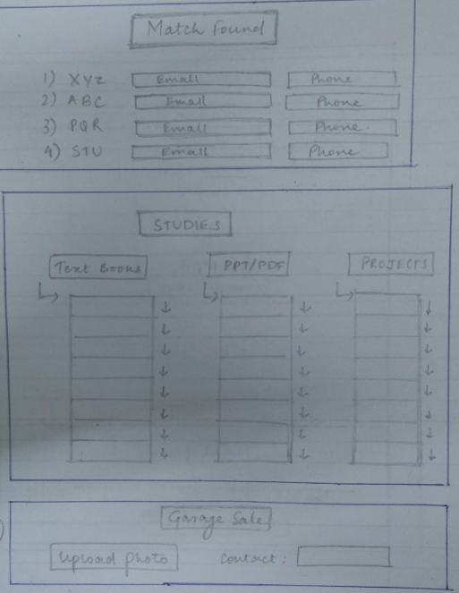
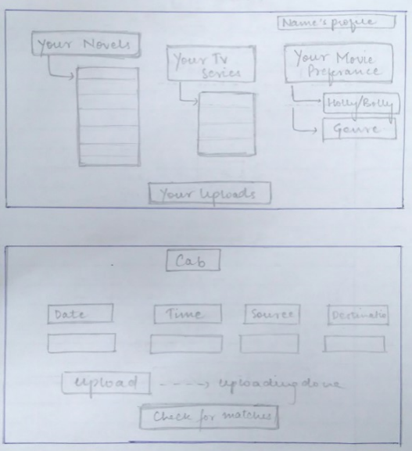
External Interface Requirements

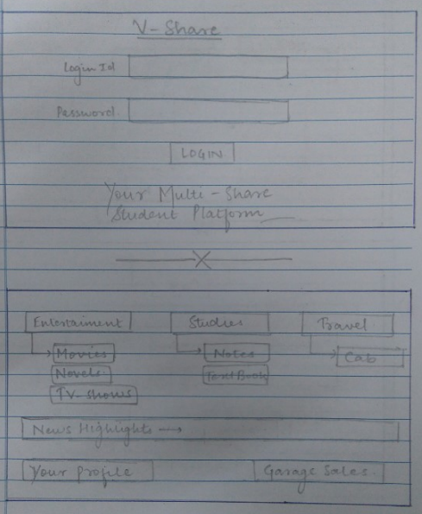
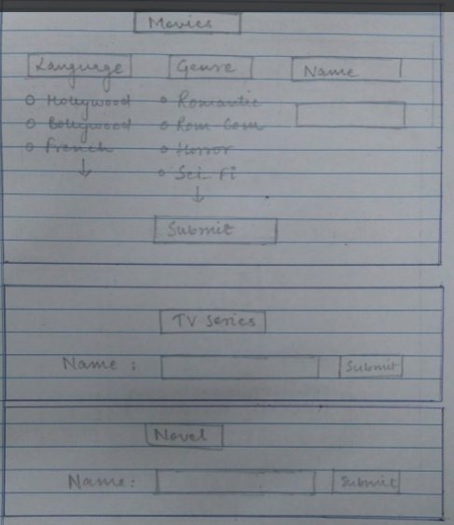

3.1 User Interfaces

3.2 Hardware Interfaces
The front-end User Interface is developed with html, CSS and Java Script. This interface is the window to what the end user sees. However, the external layer interacts with the stored Mongo database with the help of node JS scripting. The data flow is simple and is defined on the Visual Studio software framework with interactive coding.

3.3 Software Interfaces
The software is built with the definition of following frameworks:
- The database is designed using the Mongo DB framework.
- The languages (html, CSS, java script, node JS) are built upon the Visual Studio 2015 Enterprise software.
- The software is majorly designed upon the Microsoft Windows OS. However, it is created as a cross-platform forum to work over Linux and iOS as well.
- The Node JS framework: Integration with other Visual Studio features and 3 rd party tools. (Node.js, io.js, JavaScript, TypeScript, HTML, CSS, and JSON support)
- Communication protocols that interface between the front-end and back-end codes.

Communications Interfaces
The requirements associated with the product are:
- Login details: E-Mail login
- Cross platform on majorly all browsers
- Sign-up and user information via forms created by Java Script.
- HTTP is defined as the major communication standard.

System Features

4.1 Movie Sharing
4.1.1 Description and Priority
Students living in hostels pass their time mainly in front of laptop screens watching Hollywood or Bollywood movies. Hence, this feature is on the top of priority list. This app lets them share their preferred movies and ask for movies they would like having or watching. .
4.1.2 Stimulus/Response Sequences
- User needs to sign up and update his genre specification and requirement. Movies are going to categorized in languages and genre to make it easy to update the movie specifications for the user
- If user needs a movie of a particular genre, he can specify it, match it with already genre uploaded and make a demand to other user.
- If requirement of a user is fulfilled by the other user and both agree to share the movie, then their contacts are made visible.
4.1.3 Functional Requirements

Sequence number | Requirement | Service provided | Constraints
Req 4.1.1 | Login | Allows user to login | Compulsorily required
Req 4.1.2 | Update movie preferences like genres, languages. | Lets people reach out to you looking at your list. | Needs to be correct in order to stimulate exchange process
Req 4.1.3 | Look up for needed movies | Helps to find people with similar interests. | The user with matched interests should be willing to share the contact.
Req 4.1.4 | Post a request to a particular user | When matched, the user can post request to a particular person | TBD

Novel Sharing
4.2.1 Description and Priority
Hostellers majorly indulge their free time by reading various kind of novels for fun as well as expanding their mindsets. This is why this feature is on the top of the priority list
4.2.2 Stimulus/Response Sequences
- User needs to sign up and update his genre specification and requirement. Novels are going to categorized in languages and genre to make it easy to update the novel specifications for the user.
- If user needs a novel of a particular genre, he can specify it, match it with already genre uploaded and make a demand to other user.
- .If requirement of a user is fulfilled by the other user and both agree to share the novel, then their contacts are made visible.
4.2.3 Functional Requirements

Sequence number | Requirement | Service provided | Constraints
Req 4.2.1 | Login | Allows user to login | Compulsorily required
Req 4.2.1 | Update novels preferences like genres, languages. | Lets people reach out to you looking at your list. | Needs to be correct in order to stimulate exchange process
Req 4.2.3 | Look up for needed novels | Helps to find people with similar interests. | The user with matched interests should be willing to share the contact.
Req 4.2.4 | Post a request to a particular user | When matched, the user can post request to a particular person | TBD

TV-Series Sharing
4.3.1 Description and Priority
Hostellers majorly indulge their free time by watching various kind of T.V Series for fun as well as expanding their mindsets. This is why this feature is on the top of the priority list
4.3.2 Stimulus/Response Sequences
- User needs to sign up and update his genre specification and requirement. T.V series are going to categorized in languages and genre to make it easy to update the T.V series specifications for the user
- If user needs a novel of a particular genre, he can specify it, match it with already genre uploaded and make a demand to other user.
- If requirement of a user is fulfilled by the other user and both agree to share the T.V series, then their contacts are made visible.
4.3.3 Functional Requirements

Sequence number | Requirement | Service provided | Constraints
Req 4.3.1 | Login | Allows user to login | Compulsorily required
Req 4.3.2 | Update TV-series preferences like genres, languages. | Lets people reach out to you looking at your list. | Needs to be correct in order to stimulate exchange process
Req 4.3.3 | Look up for needed movies | Helps to find people with similar interests. | The user with matched interests should be willing to share the contact.
Req 4.3.4 | Post a request to a particular user | When matched, the user can post request to a particular person | TBD

Study Material Sharing
4.4.1 Description and Priority
After all the fun one has in campus, academics is still the priority. What better if we can get study material from someone, someone more experienced, our seniors. That’s why this feature is on the low priority level of this app. This app allows you to share your ppt’s etc for the reference of juniors and you can also see your senior’s academic stuff.
4.4.2 Stimulus/Response Sequences
- Projects, ppts will be categorized as sub-categories under courses. User will log in and upload his project or any other study material under these categories.
- With all these sub-categories, user can easily download any study material he wants.
4.4.3 Functional Requirements

Sequence number | Requirement | Service provided | Constraints
Req 4.4.1 | Login | Allows user to login | Compulsorily required
Req 4.4.2 | Update their projects to be available for download. | Lets people download looking at the list. | Needs to be correct in order to stimulate exchange process
Req 4.4.3 | Look up for needed projects and ppts. | Lets user to download their required | Simple download

Conveyance Sharing
4.5.1 Description and Priority
While travelling main priority of everyone is to slash down on costs as much as possible. This app lets you to share cab with others and that’s why it is on low priority list of this app. You can share your travel schedule on this app and if it matches with some other’s schedule you can pool in.
4.5.2 Stimulus/Response Sequences
- User needs to login and insert his/her travel details in the app and if some other user finds the schedule matching he can contact the user and they can pool together .
- Similarly, if the user needs to find the conveyance options he can login, search with other schedules and contact the concerned user .
4.5.3 Functional Requirements

Sequence number | Requirement | Service provided | Constraints
Req 4.5.1 | Login | Allows user to login | Compulsorily required
Req 4.5.2 | Update their travel schedule. | Lets people to pool up conveyance. | Needs to be correct in order to stimulate pooling.
Req 4.5.3 | Look up for people with similar travelling plans. | Lets user to obtain contacts of the person for pool. | Contact display.

Garage Sale
4.6.1 Description and Priority
In college life one is always in need of money and daily accessory items. There is another feature in this app with which you can share the pics of your reusable items and if someone wants it, he can contact the concerned user. This feature is on the low priority list of this app.
4.6.2 Stimulus/Response Sequences
- User needs to login for the app, click picture of his/her used item and upload in the app. So, anyone who wants the item can search for it in the app and contact the concerned user.
- If anyone wants an item, he/ she can choose it from the uploaded item and contact the concerned person.
4.6.3 Functional Requirements

Sequence number | Requirement | Service provided | Constraints
Req 4.6.1 | Login | Allows user to login | Compulsorily required
Req 4.6.2 | Update their selling item | Lets people to find what they want to sell | Needs to be correct and clear for better buyers
Req 4.6.3 | Look up for desired items. | Lets user obtain contacts of seller. | Contact display.

Use Case Diagram
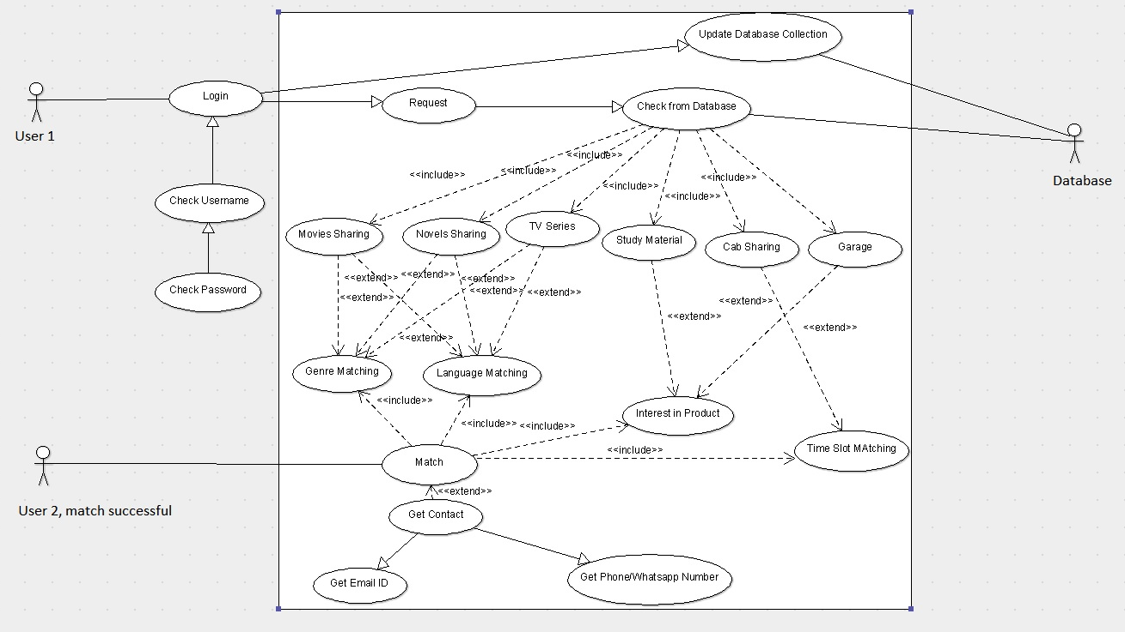

Non-functional Requirements

Performance Requirements
The performance requirements are stated as follows:
- The software is successful in the group of users that are living in a local community or campus and are open to sharing and knowing new people through a social application.
- The users prefer simple UI with an easy understanding layout. Hence, the design is completely lucid and simple.
- The sign up function (4.1.1, 4.2.1, 4.3.1, 4.4.1, 4.5.1) requires a user login through Gmail (Google accounts) or Facebook.

Safety Requirements
The software takes care of both privacy and content safety. The product is specially designed keeping the sense of sharing in mind. In case the user doesn’t want to share their respective contact publically, the user should only provide E-mail details. Contacts can be provided in case of one on one mode. The app admin can remove content, disable accounts, and work with law enforcement when we believe there is a genuine risk of physical/mental harm, violate laws or direct threats to public safety.

Security Requirements
The application is designed and developed to keep the user account safe, secure and protect their personal information. By joining the app and signing up, the user agrees to provide their authentic name and identity. The app cannot publish the personal information of users without their consent.

Software Quality Attributes
Some quality attributes of the software are listed here: adaptability, availability, correctness, flexibility, interoperability, maintainability, portability, reliability, reusability, robustness, testability, and usability.

Business Rules
The admin of the database have the right to remove or block a specific user and cease their rights to use the software in case of any breach of privacy or uploading any wrong content.

Other Requirements
Since the app is locality specific, the app can’t be generalized across demographics and on a bigger level. It can only be used in physical space areas with a locality. The database doesn’t require a physical stake hold.

*************************************************************************************

